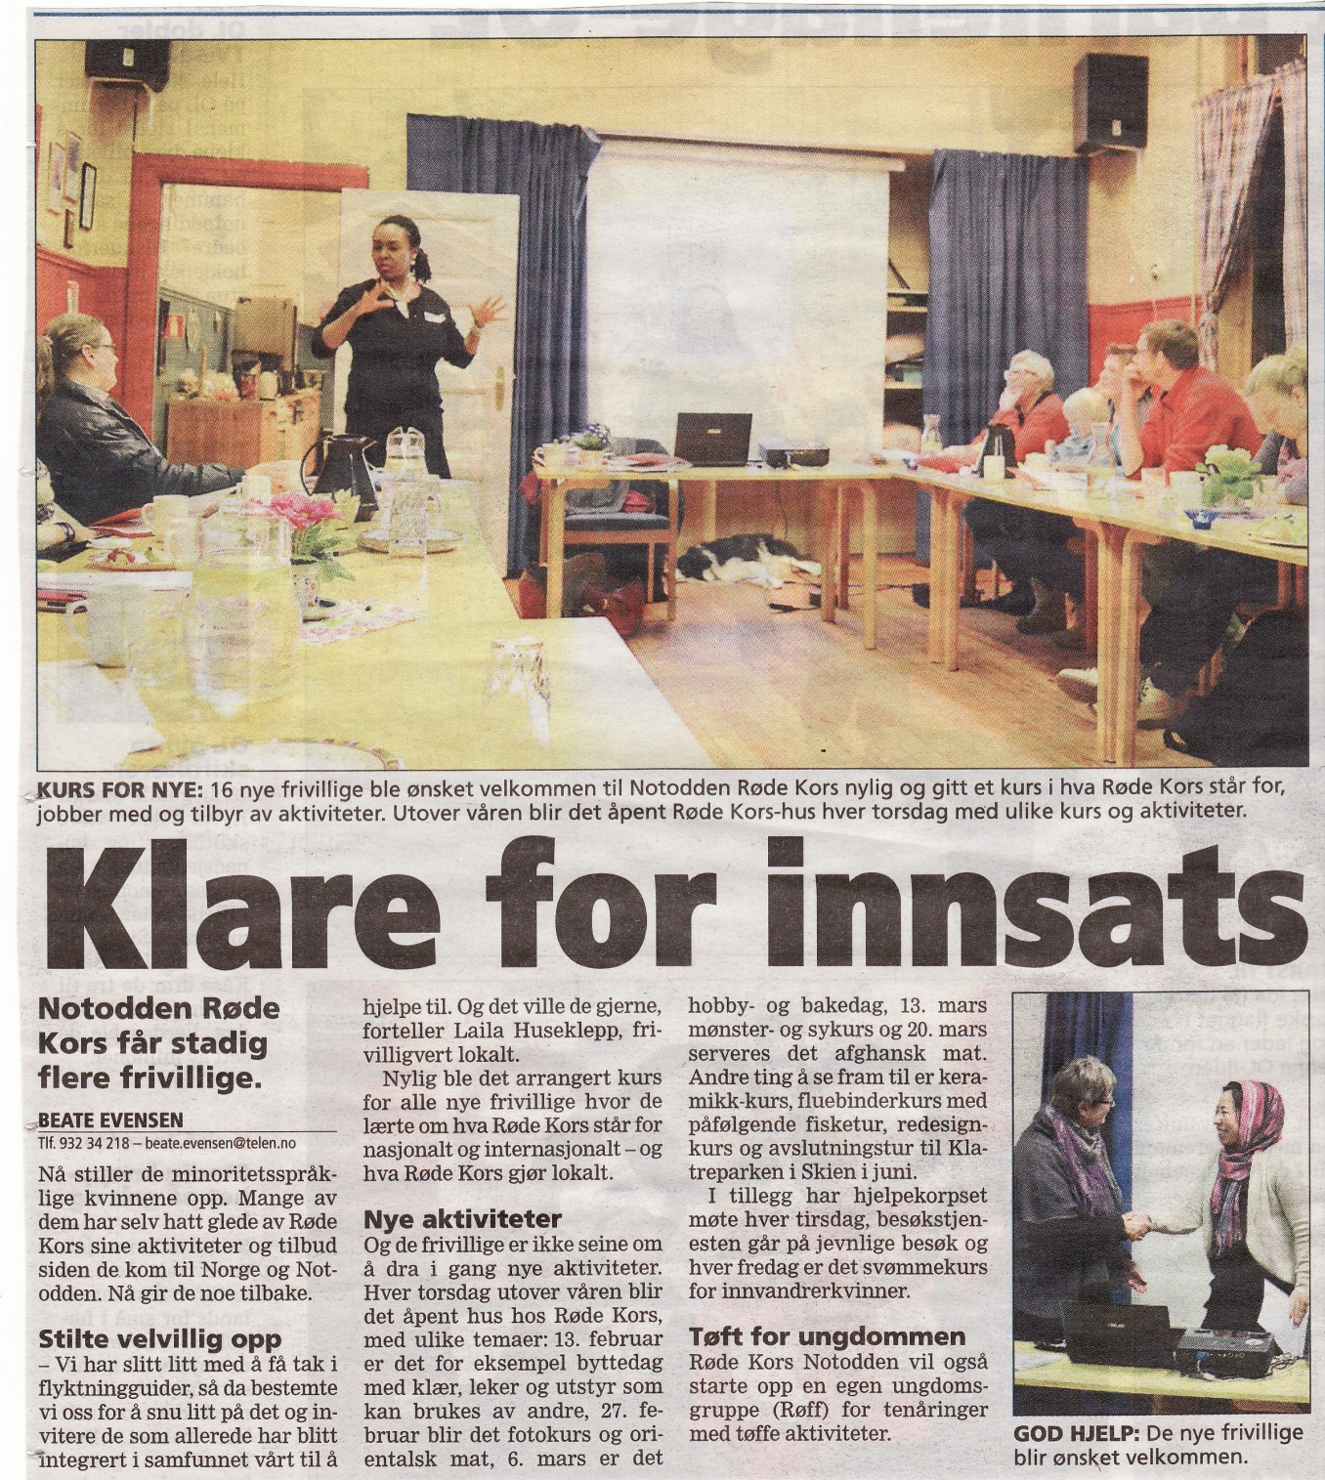
Leseforståelse

Bilde og tekst: Kopi fra «Telen» 10.2.2014

1: Skriv og fortell om det positive som skjer i Notodden Røde Kors? _____________________
____________________________________________________________________________
____________________________________________________________________________
____________________________________________________________________________

____________________________________________________________________________
____________________________________________________________________________

2: Hva har vært vanskelig i Notodden Røde Kors?
____________________________________________________________________________
____________________________________________________________________________

3: Hva var tema for det siste kurset for de frivillige?

____________________________________________________________________________
____________________________________________________________________________

4: Hva skjer hver torsdag i vår-halvåret?

____________________________________________________________________________
____________________________________________________________________________

5: Nevn to aktiviteter som er planlagt på torsdagskvelder?

____________________________________________________________________________
____________________________________________________________________________

6: Fins det tilbud for kvinner som er glad i «vann»?

____________________________________________________________________________
____________________________________________________________________________

7: Hva er «Røff»?

____________________________________________________________________________
____________________________________________________________________________

