Tema: utdanning og arbeid
Skriv setninger om bildene.
Skriv hva personene er, hvor de jobber og hva de gjør.
Kokk
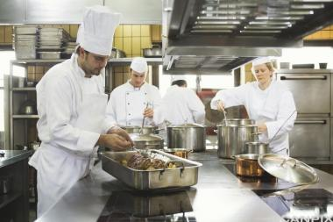
________________________________________________________
________________________________________________________
________________________________________________________
__________________________________________________________________________________
__________________________________________________________________________________
__________________________________________________________________________________
Hjelpepleier
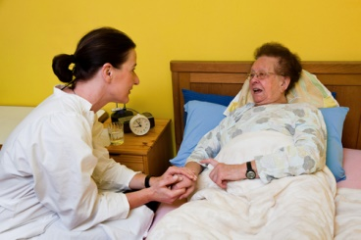
________________________________________________________
________________________________________________________
________________________________________________________
__________________________________________________________________________________
__________________________________________________________________________________
__________________________________________________________________________________

Butikkmedarbeider
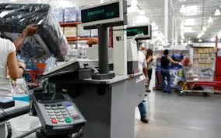
________________________________________________________
________________________________________________________
________________________________________________________
__________________________________________________________________________________
__________________________________________________________________________________
__________________________________________________________________________________
Rengjøringsarbeider
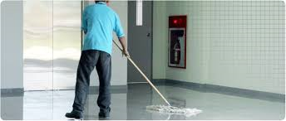
________________________________________________________
________________________________________________________
________________________________________________________
__________________________________________________________________________________
__________________________________________________________________________________
__________________________________________________________________________________

Bilmekaniker
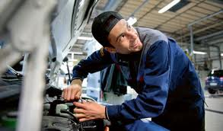
________________________________________________________
________________________________________________________
________________________________________________________
__________________________________________________________________________________
__________________________________________________________________________________
__________________________________________________________________________________

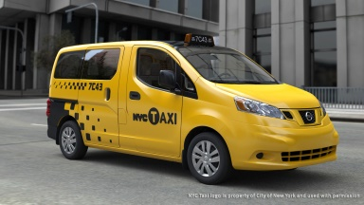
Taxisjåfør
________________________________________________________
________________________________________________________
________________________________________________________
__________________________________________________________________________________
__________________________________________________________________________________
__________________________________________________________________________________

